Email Strategy
Prepared for: <company name here>
Date: February 19, 2006

This document was developed as a template for you to use in developing an email strategy. For more detail on what should be included, see Chapter 3 of the SitePoint Email Marketing Kit, by Jeanne S. Jennings.

Prepared by: <your name here>
<your company name>
<your contact information>

Table of Contents:

Executive Summary 3
1. Competitive Analysis 4
2. Products and/or Services to Be Marketed via Email 7
3. Target Audience 8
4. Conversion Goals 9
5. Types of Email 10
6. Content Strategy 11
7. Frequency and Timing 12
8. Quantitative Goals 13

Executive Summary

Here you want to provide a brief overview (preferably one page) of the strategy. One easy way to do this is to summary each section in a single paragraph, including your key findings, but leaving the details for later in the plan.

Competitive Analysis

Here you want to summarize what you’ve learned about competitor’s use of email. It’s nice to do a brief intro describing how you gathered the information (signed up for their email lists, asked a customer to forward all their emails to you, viewed their online archive, etc.) and to include the period during which your research was done (January 2006, or Fourth quarter, 2005).

You’ll also want to include some detail on the competitors’ email schedules and the content of their emails. You can do this in excel or in word tables. You’ll need to do one chart per competitor (in the case of the overview) or per publication (in the case of the content analysis). Sample word tables for each follow:

Figure 1: Sample Competitive Overview

Competitive Intelligence
<Name of Competitor>
Type of Email | Audience | Date | Content
Promotional – Catalog | All | June 2, 2005 | All Products

Figure 2: Competitive Email Newsletter Content

Competitive Intelligence
<Name of Competitor and Email Newsletter>
Date | Contents
June 7, 2005 | News blurbs from last week (link to full text if subscriber)
 | Opinion piece on what to expect this week
 | Tip of the week for following Congress
 | Quote of the week (Congressman)
 | Poll – Will nominee be confirmed?
 | Results from last week’s poll – will the energy bill become law?
 | Ad for weekly magazine

Next you’ll want to do a SWOT analysis, covering strengths, weaknesses, opportunities and threats. Sometimes this is presented in a grid format (see below); I find it’s useful to do use bullet points, in addition to the grid, which allow you to go into more detail.

As a quick refresher from Chapter 3, here are some definitions to help:

Strengths: internal factors that make the email newsletter good; good is defined broadly, so look at things like topics that are especially relevant, writing styles that are easy to read and anything else about the content that strikes you in a positive way.

Weaknesses: these are internal factors that take away from what the email newsletter is trying to do. These might include topics covered in only superficial ways, articles that aren’t really relevant to the reader or content that is too basic, or too advanced, for the audience.

Opportunities – make a list of all the ways you think you could do better. These might include topics your competitor isn’t covering that you could, different types of content that might be more interesting to the reader or other things that would improve the reader’s experience.

Threats – these are the things your competitor does well that you could never hope to best them on. You want to list them so you avoid going head-to-head with them in your email newsletter.

Figure 3: SWOT Analysis (grid)

SWOT Analysis
<Name of Competitor and/or Email Newsletter>
Strengths | Weaknesses
Opportunities | Threats

After you’ve completed these exercises for all your key competitors, you’ll want to present your analysis, which will identify market opportunities you’ve seen during the competitive analysis.

2. Products and/or Services to Be Marketed via Email

The purpose of this section is to detail as much as you can about your company and the products and/or services to be marketed via e-mail. Be sure to include information about what’s offered as well as what advantage it offers your customers. Price should also be included here. You’ll use the list of products and services you create here as a starting point when you work on your target audiences and conversions in later sections.

Here are sample company and product write-ups, taken from Chapter 3:

Our organization, Congressional Publications, has a staff of journalists who report on what happens in Congress. We were the first media outlet to focus our efforts on Congress, we have a reputation for being fair and non-partisan and we’ve won numerous awards for our coverage. We provide news and opinion in three formats: a weekly print publication, a daily print publication and a paid content Website.

Our weekly print publication, Congress This Week, costs $100 a year. It provides highlights of the past week’s Congressional activity, including updates on the status of key legislation, who’s supporting it, who’s not and why, and expert opinion on its chances of becoming law. Our advantage here is our editorial; our staff has many years of experience watching Congress, as well as many contacts who provide insight from within chambers.

3. Target Audience

You’ll want to include a description, using as much detail as you can get, about each audience you’re targeting. Be sure to include demographic information as well as needs, benefits and advantages and the elements of the buying decision.

You may have more than one target audience, in which case you’ll want to define each separately. Also relate your target audiences to the list of products and services you plan to market via email, which you developed in the previous section.

You may have a single product that you market to more than one target audience; you may also have a stable of products and services that you market to a single target audience. This information will help you develop emails that cross-sell and upsell customers, so these relationships are important to note.

Here’s a sample target audience description, taken from Chapter 3:

Media Outlets – our target audience is small to medium sized regional newspapers that don’t have the budget to pay a full-time reporter to cover Congress. We can provide the information they need to stay up-to-date on legislation of importance to their readers for a very affordable price ($100 to $500 a year). They are very price sensitive; most purchase our weekly print publication ($100) while few are willing to pay for our more expensive online service ($500). This group is a key constituency for us; our company was founded to serve these customers. Getting a new customer in this market is a 3 to 6 month process; we usually provide a free trial of the product and follow-up via phone with tips on how they can benefit from the information. Some use the information as background for stories; others reprint our stories and vote reports verbatim in their newspapers. Our renewals in this market tend to be lower than for our other constituencies; when there are budget cuts our publications are often the first to go.

4. Conversion Goals

You’ll want to identify what you want each group that you’re targeting with email to do. In some cases you may be looking for a current customer to renew; other times you may want to cross-sell them another of your products. Here’s an example of a conversion goal plan, taken from Chapter 3:

Media Outlet Customers – our first priority here is retention, getting them to renew their current subscription(s). Since most purchase the weekly publication ($100), a secondary goal would be to cross-sell them the daily publication ($250).

Media Outlet Prospective Customers – our first priority here is selling the weekly publication ($100).

5. Types of Email

You’ll want to look at your products, audiences and conversion goals to determine which type of email to use. You’ll want to make a good case for the choice you’ve made in writing, but it’s often helpful to include a table, especially if you have a number of different types of emails. Here’s a sample:

Figure 4: Sample Email Plan

Email Plan
<Name of Company>
Target Audience | Segment | Goal(s) | Type of Email
Customers | Media Outlets | Retention – Weekly Pub | Transactional -- Invoices
Customers | Media Outlets | Retention – Weekly Pub | Relationship – Short Form Editorial
Customers | Media Outlets | Cross Sell Daily Pub | Promotional -- Postcard
Prospects | Media Outlets | Sell Weekly Pub | Relationship – Email Newsletter

6. Content Strategy

This should include any and all sources you intent to use for content. You’ll want to break it down and spell out which emails will receive content from which sources.

7. Frequency and Timing

When will you send and how often is what this section is all about. You’ll want to write about your options and why you’ve chosen the frequency and timing you have for each; after that’s it’s easy to add these to the information you’ve already gathered on your email program. Here’s a sample:

Figure 5: Frequency and Content Overview

Frequency and Content Overview
<Name of Company>
Target Audience | Segment | Goals | Type of Email | Frequency | Sent
Customers | Media Outlets | Retention – Weekly Pub | Transactional -- Invoices | Series of 6, sent every two weeks | Mondays, first sent 10 weeks prior to expire
Customers | Media Outlets | Retention – Weekly Pub | Relationship – Short Form Editorial | Weekly | Each Friday
Customers | Media Outlets | Cross Sell Daily Pub | Promotional -- Postcard | Every two weeks | Each Wednesday
Prospects | Media Outlets | Sell Weekly Pub | Relationship – Email Newsletter | Monthly | Second Tuesday of each Month

8. Quantitative Goals

This section will take the goals you’ve set above and quantify them. You may want to break your annual goals out by month, so you have a running progress report. In this case, you’ll want to create your spreadsheets in Microsite Excel or another spreadsheet program and pull them in here. There are three different tables you’ll need to create:
- Goals Spreadsheet
- Budget Estimate
- Return on Investment

You’ll find templates to use for all three in strategy.xls. Here are samples:

Figure 6: Quantitative Goals

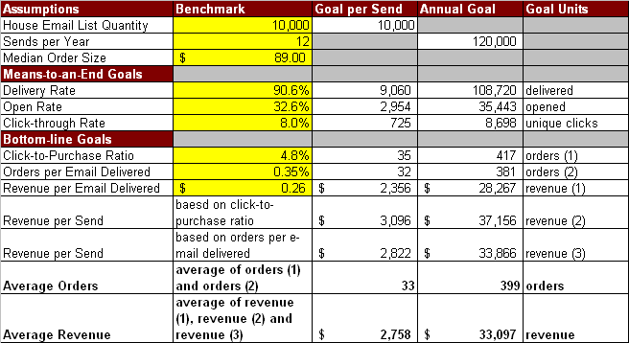

Figure 7: Budget

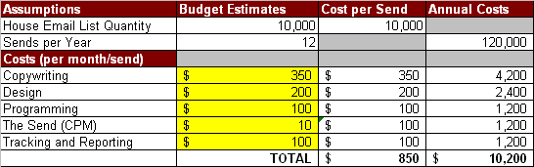

Figure 8: Return on Investment

