Email Production Brief

This document was developed as a template for you to use in creating an brief to send to your ESP or IT team so they know the particulars of the send. For more detail on email creative and production issues, see Chapter 5 of the SitePoint Email Marketing Kit, by Jeanne S. Jennings.

Prepared by: <your name>
Phone:
Email Address: <your email address>
Date:

Campaign Name:
Target Send Date:

Brief Overview of Mailing:

List(s): <name of list(s)>
If more than one, list all with files names and brief descriptions
Segmentation: describe any segmentation you need done on the list

Creative: <name of file(s)>
If more than one, list all with file names and brief descriptions

For List Segmentation/Personalization/Testing
Number of Cells:

Cell 1:
Brief Description: brief description of what differentiates this cell from the others
List: <name of list> along with any segmentation notes
Creative: <name of creative>
Display From Address:
Actual From Address:
Subject Line:
Personalization: Yes or no; if yes, list what’s being personalized (for instance, first name) and what the slug or default is (if there’s no first name in the file)

Cell 2:
Brief Description: brief description of what differentiates this cell from the others
List: <name of list> along with any segmentation notes
Creative: <name of creative>
Display From Address:
Actual From Address:
Subject Line:
Personalization: Yes or no; if yes, list what’s being personalized (for instance, first name) and what the slug or default is (if there’s no first name in the file)

Cell 3:
Brief Description: brief description of what differentiates this cell from the others
List: <name of list> along with any segmentation notes
Creative: <name of creative>
Display From Address:
Actual From Address:
Subject Line:
Personalization: Yes or no; if yes, list what’s being personalized (for instance, first name) and what the slug or default is (if there’s no first name in the file)

Cell 4:
Brief Description: brief description of what differentiates this cell from the others
List: <name of list> along with any segmentation notes
Creative: <name of creative>
Display From Address:
Actual From Address:
Subject Line:
Personalization: Yes or no; if yes, list what’s being personalized (for instance, first name) and what the slug or default is (if there’s no first name in the file)

For Dynamic Content
Typically you’ll have a spreadsheet which lists the criteria for differentiation and then what content is to pulled in dynamically. Here’s an example; this spreadsheet can be found in dynamic_content.xls.

Content Grid
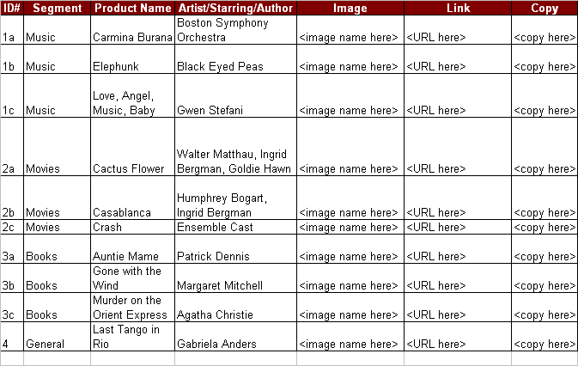

Send Final Proofs (before the send) to:
<your email address>
Add the email address of anyone else who wants to receive the final proof via email prior to the send .

Seed List (email addresses added to the send):
<your email address>
Add the email address of anyone else who wants to receive the email with the rest of th elist

